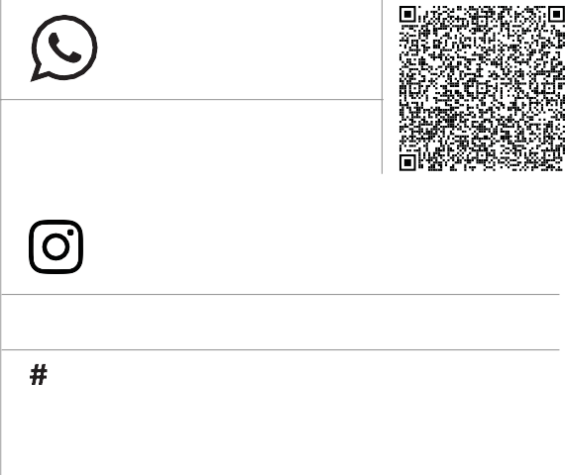

**+91 99945 78802**

**+91 96265 89922**

info@leestoreindia.com www.leestoreindia.com

@leestore_india @pandijegan.k

GSTIN 33DRNPP3773C1ZM

**4765/5, Ayyanarpuram 1st Street, Alangudi Road, Pudukkottai - 622001 Tamilnadu,India.**





|  |  |  |
| --- | --- | --- |
| Invoice No | : | <<billno>> |
| Invoice Date | : | <<billdate>> |

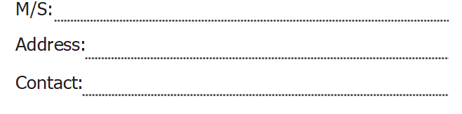

<<custname>>

<<custadd>>

<<custcont>>



|  |  |  |  |  |  |  |  |
| --- | --- | --- | --- | --- | --- | --- | --- |
|  | <<sno1>> | | | <<h2>>  <<h1>> |  | <<q1>>  <<q2>> | <<up2>>  <<up1>> |
| <<description3>>  <<sno3>>  <<sno2>> | | <<description2>> |  | <<up3>>  <<q3>>  <<h3>> | | | | | <<amt2>> | | <<amt3>>  <<amt1>> | |
| <<description4>> | |  | | **<<**up4**>>** | | | |  |  | | |
| <<sno4>> | |  |  | <<up4>>  <<q4>>  <<h4>> | | | |  | | <<amt4>> | | |
| <<sno5>> |  | <<description5>> | | <<h5>> | | <<q5>> | | <<amt5>>  <<up5>> | | | | |
|  | <<description6>>  <<sno6>> | <<description2>> | <<description2>> | <<q6>>  <<h6>> | | | <<amt6>>  <<up6>> | | | | | |
|  |  |  |  |  | | | <<cgst>>  <<sgst>>  <<total>>  <<total>> | | | | | |
|  |  |  |  |  | | |  | | | | | |

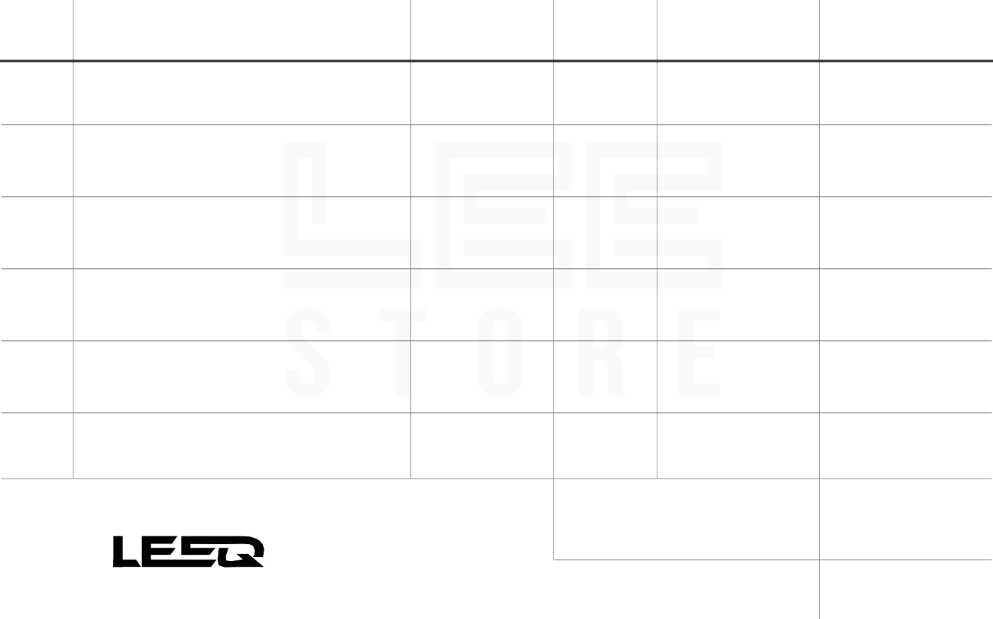

**S.NO DESCRIPTION OF GOODS**

**HSN/SAC**

**QTY**

**UNIT PRICE**

**AMOUNT**

**CGST % SGST %**

**TOTAL**

<<description1>>



Term & Conditions

Note: Mobile handset and laptop system and all electronics goods

are warranted for a period defined by the respective manufactures against

defect in material & workmanship Lee Store is not given warrant

and does not hold out any warranty of product sold.

**GOODS RECEIVED IN WORKING CONDITION**

SALES PERSON:

for LEE STORE





www.leestoreindia.com

Customer Signature Signature